MULTIPLE REGRESSION ANALYSIS

What is Multiple Regression
In single linear regression we predict one quantitative variable by using other quantitative variable.
XY
Y=a+bx
We have two coefficients in single linear coefficients. One is slope and other is intercept of the best fitting line and easy to interpret.
In Multiple linear regression uses more than one x variable to estimate the value of y.
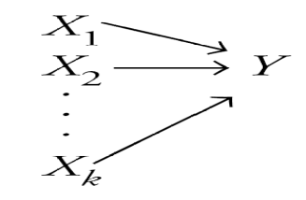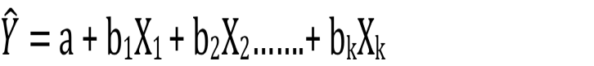
In linear multiple regression we have multiple coefficients. It is the amount by which y changes when that particular x increases by one unit with the values of all the other independent variables held constant.
The coefficient of an x variable in a multiple regression model is the amount by which y changes if that x variable increases by one and the values of all other x variables in
the model don’t change. So basically, you’re looking at the marginal contribution of
each x variable when you hold the other variables in the model constant.

Example
An Estate agent sells homes along the east coast of the United States. One of the questions most frequently asked by prospective buyers is: If we purchase this home, how much can we expect to pay to heat it during the winter? Three variables are thought to relate to the heating costs: (1) the mean daily outside temperature, (2) the number of inches of insulation in the attic, and (3) the age in years of the furnace. To investigate, the estate agency’s research department selected a random sample of 20 recently sold homes. It determined the cost to heat each home last January, as well .
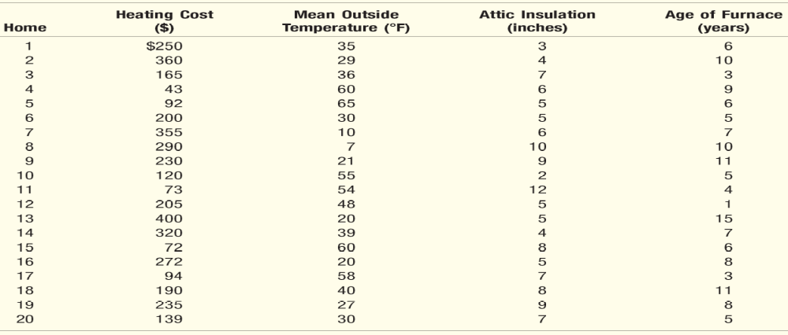
The multiple regression equation is as follows.
Question: What is the estimated heating cost for a home if the mean outside temperature is 30 degrees, there are 5 inches of insulation in the attic, and the furnace is 10 years old?

Y= 427.194 - 4.583 (30) - 14.831 (5) + 6.101 (10) =276.56

